Query a list of CITY names from **STATION** with even ID numbers only. You may print the results in any order, but must exclude duplicates from your answer.

**Input Format**

The **STATION** table is described as follows:

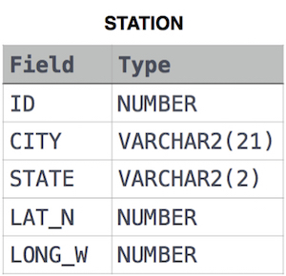

where LAT_N is the northern latitude and LONG_W is the western longitude.

Solution:

SELECT DISTINCT CITY

FROM STATION

WHERE MOD(ID,2)=0;